**COSC 5328**

**Summer 2015**

**Collaboration Statement**

**Name: SHUBHASHISH MISHRA (L20365063)**

**Date: 08/14/2015**

**Title of Assignment: AIRLINE RESERVATION SYSTEM**

**List of all Collaborators:**

1. **BALRAM AGRAWAL**
2. [**http://tilde.town/~cristo/file-locking-in-python.html**](http://tilde.town/~cristo/file-locking-in-python.html)
3. [**https://docs.python.org/2/library/fcntl.html**](https://docs.python.org/2/library/fcntl.html)
4. [**http://www.tutorialspoint.com/python/python_command_line_arguments.htm**](http://www.tutorialspoint.com/python/python_command_line_arguments.htm)
5. [**https://docs.python.org/2/tutorial/errors.html**](https://docs.python.org/2/tutorial/errors.html)
6. **https://docs.python.org/2/tutorial/inputoutput.html**
7. **Text Book: TCP-IP Socket In C: Practical Guide for Programmer, Michael J. Donahoo and Kenneth L. Calvert**
8. **Text Book: Computer Networking: A Top-Down Approach, James F. Kurose and Keith W. Ross**

**OR Circle this statement: “I DID THIS ASSIGNMENT ON MY OWN.”**

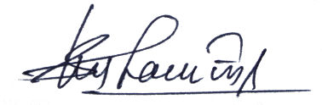

**STUDENT SIGNATURE: _______________________________________**